Annexure: I
- SCOPE OF WORK
M/S NEXTBRIDGE PVT LTD. (the “Contractor”) will provide the ISMO Website development (Documentation, Training, three years Domain registration & Hosting and Initially one year Support) at the CPPA-G Islamabad. Project scope is to build ISMO online presence by developing web application for public and market participants. This application would provide easy access to ISMO staff to share and post information. Through this application Market Participants would be able to review their billing statements.

- DEVELOPMENT PHASES
ISMO online web application will be developed in 2 phases. In Phase 1 all feature set related to CMS website will be completed. The Contractor will be responsible to includes Front-end application for public and admin panel for ISMO staff. Landing page will be kept simple and sophisticated with images been localized. Look and feel of website will be clean, sleek, and minimalistic. A dynamic menu structure will be provided that allows users to effortlessly add, update, move, and delete menu items across the site's structure. The Contractor will provide ISMO Library for ddocuments related to regulations, announcements, reports etc. A dynamic menu structure will be provided that allows users to effortlessly add, update, move, and delete menu items across the site's structure. An aactivity based logs will be maintained for all roles. Automatic sitemap will be updated whenever the content creator adds, edits, or deletes any content. All non-PDF documents will be automatically converted into PDF when uploaded from admin panel. The Contractor will be responsible to develop a Complaint management tool that will be available for Market Participants to generate complaints and ISMO department to review and manage these complaints. From dashboard, MP would be able to view Total no. of complaints, Total no. of complaints resolved, Total no. of complaints unresolved. Along with this, the contractor will provide a simple contact us form will be provided where user will enter his personal details along with query. Market participants will have the option to receive important notices through email. There will be a FAQ section on admin portal. Job posting section will be available on ISMO for recruitment process. ISMO website would be multi-lingual website. Primary language would be English. Secondary language would be Urdu. Social Media accounts Facebook, Twitter and LinkedIn will be integrated with the website. Functionality of ChatBot will be implemented where user will be able to ask query and ChatBot will answer accordingly to available knowledgebase. Guest user will be able to subscribe for RSS feed
In Phase 2, the contractor will be responsible to develop Market Participant portal along with 3rd party API integrations. Complaint Management and Discussion Forum features will be included in phase 2 development.
The overall website will be responsive and will support Apple Safari, Google Chrome, Microsoft Internet Explorer and Edge, and Mozilla Firefox. DDoS and other cyberattacks will be mitigated and a mechanism will be deployed to detect malicious activities. Code and database backup will be maintained. SSL certificate will be installed on server to encrypt data in site communications. Dedicated web hosting will be purchased for ISMO by M/S NEXTBRIDGE PVT LTD.

PURPOSE OF DOCUMENT
This is an overview of the requirements for a new web-based solution for Independent Systems and Market Operators (ISMO). ISMO shall be unaffected by actions linked to power generation, ensuring that all generators are treated equally. ISMO will primarily deal with capacity and energy imbalances.
This document not only describes the key features and functional requirements, but also the non- functional requirements. This document will lead the design and execution of the target system as well as the project's scope. Any requirement not mentioned in this document will be considered out of scope for this project.

PROJECT SCOPE
Project scope is to build ISMO online presence by developing web application for public and market participants. This application would provide easy access to ISMO staff to share and post information. Through this application Market Participants would be able to review their billing statements.

PROJECT RISK
Following are some of the risks identified during project development:

- Delay in finalizing organization name which would affect designing logo and web application theme.
- Delay in approving logo and theme design.
- Delay in providing 3rd party APIs for integration in Public and Market Participant portal

DEVELOPMENT PHASES
ISMO online web application will be developed in 2 phases. In 1st phase all feature set related to CMS website will be completed. This includes Front-end application for general public and admin panel for ISMO staff.
In Phase 2, Market Participant portal will be developed along with 3rd party API integrations. Discussion Forum is not part of RFP but as discussed Nextbridge will develop this feature.

Complaint Management and Discussion Forum features will be included in phase 2 development.

CMS WEB FEATURES

ISMO WEBSITE THEME
Front-End and Admin panel will have separate theme. For Front-End custom theme will be designed and webmaster will have option to select from 3 pre-defined theme. For admin panel, open-source Admin LTE responsive theme will be utilized.
Name of the application or organization is not finalized yet but as discussed home page will be designed based on corporate colors closer to blue tone which is also used in CPPA-G website. Localized content should be displayed on website. Website should be designed considering minimalistic design approach. It should be clean and uncluttered designs. In 1 theme, there should be 4 main menu categories on top menu and all other links will be displayed either on sub menu level or on footer.
ISMO website should be responsive hence its layout should also adjust on mobile or tablet screen accordingly.
On home page basic stats will be displayed and details should be on inner pages. Corporate information or About us info will in inner pages. Social media links will be on footer.

ISMO DASHBOARD
ISMO staff/Content Creators would be able to login and view dashboard. On this dashboard following components/widgets will be available:
- Shortcuts / Quick links
- Items requiring Actions.
- Activity Log
- Recently updated information
- Content reaching expiration date.

CONTENT MANAGEMENT
Content Management module will have both option to either add content through HTML or user can simply add text & images and publish it on website. Only webmaster or Level 2 role can

modify HTML. For HTML modification, level 2 role would be able to use general HTML tags like paragraph <p> and heading <h> tags.
Content Management module will provide following options:

- Content States: Following four states of content will be maintained: Save as Draft
Published
Unpublished (For expired content) Scheduled (For future scheduling)
- Content Modification: Content Creator would be able to add, modify, remove, or move content using an easy-to-use editor.
- Content Preview: Content Creator will be able to preview the content before publishing it. Content will be opened in new tab for preview.
There will be no approval mechanism for content publishing as all content will be pre- approved.
- Content Expiry: For time-sensitive content, user will be able to set an expiration date and time. User will also receive an expiration notice. This notice will also appear on the Admin’s dashboard.
- Content Scheduling: From admin panel content creator will have option to schedule CMS content, news, blogs etc. Content will be published on scheduled date and if expiry date provided, then content will be unpublished automatically.
- WYSIWYG Editor: While offering flexibility for higher-end content contributors, the CMS will have a sophisticated WYSIWYG rich text editor for content additions and modifications that is easy and uncomplicated, giving content contributors a basic set of choices to alter/modify content.
- Banner: Two options will be provided to upload banner. User can either upload new banner or add a link from media library.
- Spell Check: Content Editor should have a spell checker that would help in eliminating any errors.
- User Friendly URL: System will automatically generate user friendly URL’s for newly created pages. URL routing will be provided along with meaningful URL’s.

ISMO LIBRARY
Documents related to regulations, announcements, reports etc. will be included in the ISMO Library. A CRUD will be provided in the Admin portal along with a list to view the documents. Visitors will be able to download the documents from front-end. Before any visitor can download documents, system would capture visitors Name and email, once provided then content will be downloadable. All downloadable content will be converted into PDF document before downloading.

GRAPHICS MANAGEMENT
In this section, webmaster has option to add/edit images for different sections of front-end website. Webmaster will upload image along with title, description, meta tags and keywords. Webmaster will be able to upload images with specific size and dimensions so that it does not affect front-end application layout.

MENU MANAGEMENT
A dynamic menu structure will be provided that allows users to effortlessly add, update, move, and delete menu items across the site's structure. User will be able to add infinite number of menu levels. User will be able to handle the order of menu’s and sub-menu’s manually. On front-end home page, top menu will have 4 main menu items which will have sub menus. Corporate / About Us info will be links on top of top menu.

BROKEN LINK
System will display list of all broken links in admin panel. User will be able to view and rectify the link.

SEARCH STATISTICS
Site search statistics will be displayed in back portal. User can either export the results or filter and sort the results based on date and time criteria.

WEB ANALYTICS
Google analytics will be integrated with the website. Specific analytical data will be displayed in Admin portal dashboard. Type of data displayed in admin portal will be based on export permissions provided by Google Analytics.

ROLES & PERMISSIONS
Webmaster will have access to roles and permissions section where webmaster can create new roles and assign permissions. By default, Content Creator level 1 and level 2 roles will be provided along with super admin and market participant role. Webmaster can modify permissions for these roles.
Additionally, Department role will be created as well, which will be assigned to department accounts.
Following roles will have these permissions by default:
- Webmaster: Has all permissions
- Level 1: Can only do Data Entry and content publishing and HTML part will be locked.
- Level 2: Can have Level 1 access along with HTML changes.
- Market Participant: Access to market participant portal
- Department: Has access to department account in admin panel to manage complaints from market participants
Activity based logs will be maintained for all roles and webmaster will have access to logs.

AUTOMATIC SITEMAP
A sitemap will be regularly updated. The sitemap and on-page breadcrumbs will be updated whenever the content creator adds, edits, or deletes any content.

PDF CONVERTOR:
All non-PDF documents will be automatically converted into PDF when uploaded from admin panel. It will be a background process. Guest or Market Participants when try to download these documents, only PDF document version will be downloadable. Additionally, guest name and email will be captured before downloading document.

DESIGN AND THEME
Landing page will be kept simple and sophisticated with images been localized. Look and feel of website will be clean, sleek and minimalistic. All the pictures will be vetted by ISMO before adding onto website. In one of the templates, there will be four fixed main menus on the top of the screen. All these menus will have further sub-menus. Corporate / About us info links will be

available on top of menu. Corporate / About us information will be on inner pages not on home page.
Three sets of pre-defined themes will be provided in back end. Theme change will be implemented on whole website. Content area layout will not be changed. Only appearance of website will be changed.

COMPLAINT MANAGEMENT TOOL
Complaint management tool will be available for Market Participants to generate complaints and ISMO department to review and manage these complaints.

Complaint Management Tool for Market Participants:
Market participants will login to the MP portal using their own credentials. User information from the profile will be auto populated in the complaint form. MP will select department for the complaint from the drop-down menu. MP will fill out the complaint form and submit it. MP has option to upload any document for evidence as well.
MP would be able to perform following activities:
Create new complaints Select department
Enter details
Upload any document
View List of all complaints generated by MP View ticket status and details
From dashboard, MP would be able to view following stats:

Total no. of complaints
Total no. of complaints resolved Total no. of complaints unresolved

Manage Complaints:
Pre-defined department account will be provided to ISMO. When MP generates a complaint for any of these department, ticket will be automatically assigned and available for review in respective department accounts.
From department accounts, staff would be able to perform following activities:

View list of complaints View complaint details Add comments
Download documents in complaint Upload any document
Mark ticket forwarded to external organizations. (ISMO will provide list of external organizations)
Update complaint status

On dashboard, ISMO departments would be able to view following stats:

Total Tickets
Resolved Tickets Open Tickets
Average Close time of ticket.

Reports:
Departments will have option to generate report consisting of all tickets and their statuses.

CONTACT US
A simple contact us form will be provided where user will enter his personal details along with query. In admin panel, every submitted query will be listed under contact us section. ISMO staff would be able to view list and details of each query.

E-NOTIFICATIONS
Market participants will have the option to receive important notices through email. They will have the ability to opt in/opt out to receive e-notifications. To receive e-notifications, a valid and verified email address is mandatory.

E-NEWSLETTER
E-Newsletter subscription service will be provided so that users can receive newsletter through email. Guests can subscribe for newsletter by provide name and email. From admin panel, ISMO staff would be able to see list of users subscribe for newsletter and send them email content.

EMBEDDED AUDIO/VIDEO/MEDIA
Easy embedding of audio, video and media with associated embed code will be provided.

FAQ TOOL
A FAQ section will be provided on front-end website. ISMO would be able to add FAQ from admin panel. ISMO would be able to publish and unpublish FAQs.

GIS MAPPING (OPTIONAL)
Initially this feature will not be implemented. This could be required in support period. A map will be displayed will locations marked on it.

IMAGE MANAGEMENT
Image management tools for the addition of images to on-site content.
- Editing: Image editing abilities on uploaded images, including the ability to change opacity, resize images dynamically based on width and height, flip images, rotate images, and crop images.
- Multiple Upload: Capacity to upload multiple images at one time and associate images with specific pages; the maximum file size should be no less than Two (2) megabytes.

JOB POSTS
ISMO HR will have option to add, edit and delete job ads by providing job details. Job title, Job description, Experience Required, Qualification and How to Apply will be posted on Front end website. Images and documents can also be uploaded while posting the job. HR would be able to enable or disable standard FORM to apply for the job online. If enabled, candidate will have to provide basic details along with CV to apply for job. HR would be able to view list of all candidates that have applied for job for each job ad. There will be ability to extract list of candidates and details in CSV.

LANGUAGE TRANSLATION
ISMO website would be multi-lingual website. Primary language would be English. Secondary language would be Urdu. Google translator will be used to convert language to Urdu.

ONE-CLICK SOCIAL MEDIA
Social Media accounts Facebook, Twitter and LinkedIn will be integrated with the website. Icons will be provided in the footer of website. Front End will only display social icons with URL’s linked to them. One click posting is dependent on third party API’s. Content Creators would be able to share content on social media after publishing it. Content Creators will have to share content

separately for each social media directly from admin panel. Social Feed will not be displayed on front-end.

PHOTO SLIDESHOWS
On Front-end website there will be section for Photo Slideshow. ISMO staff will have option in admin panel to upload photos or choose from media library. Also they have to alter the order, speed, transition type and duration of on-site slideshow from back end.

SOCIAL MEDIA INTEGRATION
Front End will only display social icons (Facebook, Twitter and LinkedIn) with URL’s linked to them. Social Feed will not be displayed.

NEWS POSTING
A dedicated news section will be provided where website users can view latest news related to ISMO and ISMO activities. ISMO will have options to publish/unpublish news from admin panel. They can also save content as draft. An editor will be provided that would allow content creators to add and modify text, add and resize images and spell check. When news or any event is posted it will be connected with RSS feed.

ACCESSEBILITY ADD-ONS
Following accessibility add-ons must be provided on the website:
- Change Font size.
- Audible content.

ADVANCED SITE SEARCH
Search will be based on metadata. Internal search will have following functionalities:
- Sort: Users should be able to sort search results by date, content, title, or relevance.
- Filter: Users should be able to filter by type of content and easily apply advanced search techniques such as Boolean, if desired.
- Search Optimization: User should be able to tune the search results by using synonyms for common words or terms and promote pages using keywords.
- Document Search: Search functionality would search title and description provided before uploading any document. Based on it search results will be displayed to public.
- Internal Search: Search will be based on ISMO website and no external search from google or other sites will be incorporated.

3rd PARTY API INTEGRATION
In ISMO online website few APIs will be integrated from 3rd party systems. Stats and data displayed on landing page and inner pages will be displayed using these API integrations.
Following are some stats that will be displayed on landing page:
- Load Forecast
- Load Data
- Marginal Price

Details along with other stats will be displayed on inner pages. Similarly, stats and details displayed for each Market Participant will be displayed using 3rd party API.
API integration will be part of phase 2 development after ISMO internal software are developed and APIs are available.
Additionally, few APIs like MP registration API will be exposed to other systems. These APIs will be developed and discussed in later stages of development.

RSS FEEDS
Guest user should be able to subscribe for RSS feed. Through RSS feed user would be up to date on important events, news, and announcements from the website.

MEGA MENUS
The solution should provide capability for fully customizable mega menus. System would automatically create menu based on content published. ISMO will have option to add, remove and change order of navigation.

IFRAME FUNCTIONALITY
The solution should have iframe functionality to seamlessly embed other documents within any HTML page. Examples of embedded content include videos, third party applications, Slide Share documents, etc.

DOCUMENT ARCHIVE
A document archiving feature would be available where ISMO can archive documents into different categories. If these documents are published, then they will be displayed on front-end and will appear on search results. Guest users can download PDF documents from archived section by providing Name and Email.

MARKET PARTICIPANT PORTAL
In Phase 2 Market Participant portal will be developed. Only Market Participants will be able to access this portal to review Preliminary Settlement statement, balancing mechanism of energy results, extraordinary settlement statement and final settlement statement.
- Registration: Market Participants will be registered on ISMO internal systems. Initially ISMO online website will provide online registration FORM or registration documents. Later on APIs will be exposed to share registration details with ISMO internal systems.
- Authentication: Market Participant user will get authenticated from ISMO internal system. MP will be login successfully into MP portal when successfully authorized from ISMO internal system.
- Reports: Market Participants would be able to review reports. All data will be fetched from ISMO internal system and displayed on MP Portal.

CHATBOT
ChatBot will be developed for guests on ISMO online website. On bottom right cornor of ISMO website there will be an icon for ChatBot. Clicking that icon will open small window for ChatBot. User will be able to ask query and ChatBot will answer accordingly to available knowledgebase. Before user can start chat, they will have to provide Name, Email, Company (optional) and phone number. User will also have option to enable whether to receive chat transcript in their email. If Bot will be unable to answer the query, then user will have option to leave message for ISMO staff. A description box will appear that would allow user to add description. Query will be added to contact us list in admin panel.
From admin panel ISMO staff can view details about the query. In admin panel, ISMO staff will have option to add question and answers which would become knowledge base for ChatBot.
For all ChatBot sessions, system would capture chat and send it to ISMO specified email address.

DISCUSSION FORUMS
Discussion forums will be available for Market Participants and ISMO staff. ISMO staff will be able to create new forum threads. Forums can be published, unpublished or closed. Published forums will be displayed on MP portal. ISMO staff will be able to add, hide or remove comments. Market Participant would be able to view list of forums along with their details. They would also have option to comment on these forums. Discussion forums will be developed in phase 2 after completion of other modules.

NON-FUNCTIONAL REQUIREMENTS

BROWSER SUPPORT
New ISMO website will be responsive and it will support following browsers:
- Apple Safari
- Google Chrome
- Microsoft Internet Explorer and Edge
- Mozilla Firefox

DDoS MITIGATION
DDoS and other cyberattacks will be mitigated and a mechanism will be deployed to detect malicious activities.

DISASTER RECOVERY
Code and database backup will be maintained and in case of any disaster a recovery time of 60 minutes or less will be taken to get the website up and running again.

PAGE LOAD TIME
The solution will ensure that pages load in 1.5 seconds or less on average.

SYSTEM UPTIME GUARANTEE
99.9% system uptime will be provided.

WEB HOSTING
Dedicated web hosting will be provided for this project.

DEVELOPMENT, TEST AND LIVE ENVIRONMENT
A development and test environment will be established so that the CPPA-G IT team may use them for future enhancements and support. All project details will be handed over to the CPPA-G IT personnel after the project is completed.

SSL CERTIFICATE:
SSL certificate will be installed on server to encrypt data in site communications.

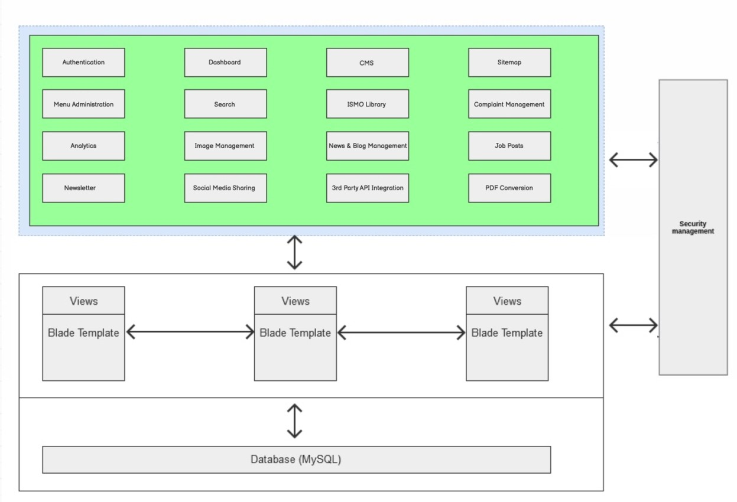
WEBSITE ARCHITECTURE
16 | P
For ISMO online website will layered and three tier architecture.
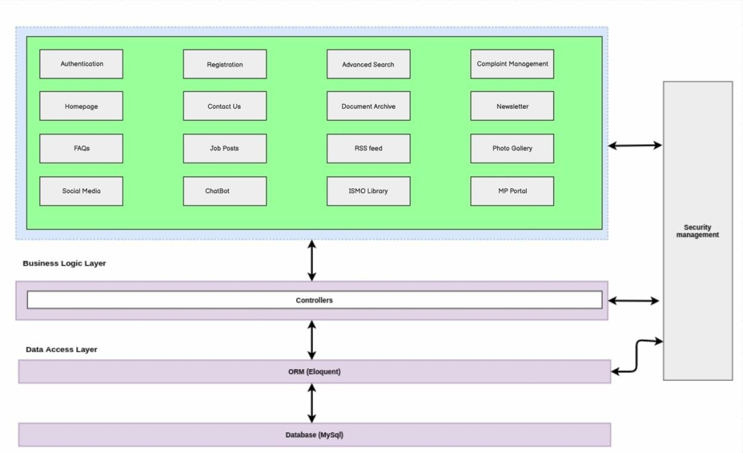
- Front-end ReactJS Architecture Diagram
- Back-end Architecture Diagram

a g e

TECHNOLOGY STACK
Following is technology stack for ISMO online website:
- ReactJS
- PHP, Laravel
- MySQL
- JavaScript
- HTML/CSS

Front-End Website Structure
- Site will be a Single Page Application which will be built using ReactJS components.
- Layout will be completely responsive. Consistent display will be provided across all resolutions to cope different devices like mobile phones, tablets and laptops.

Back-End Website Structure
Application backend will be built using a widely used PHP Framework Laravel.
Laravel is known for its MVC architectural pattern, Modular Packaging System, dedicated dependency manager and for the different ways available in it to access and communicate with relational databases.

Administration Panel:
Admin panel is the heart of the back-end access to the Web Portal. Available only through secure login, this is a place where admins would manage the front-end website content. Through this application, the admin would be able to authorize and deploy new content uploaded.

Database:
All information submitted and received goes through a database housed on the same server that serves the website. By employing the database (either SQL Server or MySQL) the portal is constantly dynamic.

Application Architecture:
Application will be built using layered architecture approach. ReactJS will be used as a client side framework, which will make site highly interactive and independent from business logic. All business logic will be present in the rest API. And all data will be stored in a secure MySQL DB. Separation of concerns among these logical layers and components provide increased flexibility, maintainability, and scalability.
- Technical Reports
The Contractor will provide all maintenance reports performed, including the routine preventive maintenance practices and fault reports, as required by CPPA-G and shared between CPPA-G’s technical team and the Contractor’s service teams as necessary. Reports required by CPPA-G’s management regarding the status of the system and any issues relating thereto will be provided by the Contractor as and when required.

